**PATFIN NURSERY AND PRIMARY SCHOOL, AKESAN, LAGOS STATE.**

**THIRD TERM EXAMINATION [ 2017 / 2018 ]**

**CLASS : NURSERY 1**

**NAME : ______________________________________ SUBJECT: SCIENCE**

**INSTRUCTION : ANSWER ALL QUESTIONS DURATION : 1 HOUR**

1. The immediate treatment given to an injured or a sick person is called _______ (a) Second chance (b) First Aid (c) Forth and Treatment
2. Mention four(4) sources of water

____________, ___________.

_____________, ____________.

1. Water is used for washing and bathing [ True / False ]
2. Any water that is smelling is not safe for drinking [ Yes / No ]
3. Typhoid fever is caused by drinking unclean water [ True / False ]

**PATFIN NURSERY AND PRIMARY SCHOOL, AKESAN, LAGOS STATE.**

**THIRD TERM EXAMINATION [ 2017 / 2018 ]**

**CLASS : NURSERY 1**

**NAME : ______________________________________ SUBJECT: HEALTH – HABIT**

**INSTRUCTION : ANSWER ALL QUESTIONS DURATION : 1 HOUR**

1. Diseases can be transmitted through ______ (a) Fishes (b) Cockroaches (c) Lizards
2. Dirty water can cause skin rashes. [ True / False ]
3. Do you need to wash your hands after eating? [ Yes / No ]
4. Should you drink dirty water? [ Yes / No ]
5. Eating unclean fruits can cause diseases [ True / False ]

**PATFIN NURSERY AND PRIMARY SCHOOL, AKESAN, LAGOS STATE.**

**THIRD TERM EXAMINATION [ 2017 / 2018 ]**

**CLASS : NURSERY 1**

**NAME : ______________________________________ SUBJECT: SOCIAL NORMS**

**INSTRUCTION : ANSWER ALL QUESTIONS DURATION : 1 HOUR**

1. Is it dangerous to cut any part of your body? [ Yes / No ]
2. Gender means whether you are a boy or a ____ (a) Man (b) Woman (c) Girl
3. A child who greets is loved by every one [ True / False ]
4. Must you abuse your parents or anybody? [ Yes / No ]
5. People bleach their skin with the help of special body _______ (a) Oil (b) Cream (c) Water

**PATFIN NURSERY AND PRIMARY SCHOOL, AKESAN, LAGOS STATE.**

**THIRD TERM EXAMINATION [ 2017 / 2018 ]**

**CLASS : NURSERY 1**

**NAME : ______________________________________ SUBJECT: P . H . E**

**INSTRUCTION : ANSWER ALL QUESTIONS DURATION : 1 HOUR**

1. Hop like a frog [ 5 Times ]
2. Spin around
3. Fly like an aero plane [ 5 Times ]
4. Hop on one leg [ 5 Times ]
5. Jog to the gate [ 5 Times ]

**PATFIN NURSERY AND PRIMARY SCHOOL, AKESAN, LAGOS STATE.**

**THIRD TERM EXAMINATION [ 2017 / 2018 ]**

**CLASS : NURSERY 1**

**NAME : ______________________________________ SUBJECT: FOOD AND NUTRITION**

**INSTRUCTION : ANSWER ALL QUESTIONS DURATION : 1 HOUR**

1. Food supplements are food that makes us grow [ True / False ]
2. Mention four(4) foods that make you grow

_____________, ____________.

______________, ______________.

1. Food supplements help to __________ (a) Immunity (b) Community (c) Body
2. Is it a good habit to check the expiry dates of products [ Yes / No ]
3. An example of food supplements is vitamin C [ True / False ]

**PATFIN NURSERY AND PRIMARY SCHOOL, AKESAN, LAGOS STATE.**

**THIRD TERM EXAMINATION [ 2017 / 2018 ]**

**CLASS : NURSERY 1**

**NAME : ______________________________________ SUBJECT: MORAL INSTRUCTION**

**INSTRUCTION : ANSWER ALL QUESTIONS DURATION : 1 HOUR**

1. When a teacher is standing before you, You must be ______ (a) Noisy (b) Silent (c) Rude
2. Should you keep your home work undone till the next day? _______

[ Yes / No ]

1. We must learn to say the truth all times [ True / False ]
2. Those telling lies are ________ friends. (a) Bad (b) Good (c) Nice
3. A good child is hardworking. [ True / False ]

**PATFIN NURSERY AND PRIMARY SCHOOL, AKESAN, LAGOS STATE.**

**THIRD TERM EXAMINATION [ 2017 / 2018 ]**

**CLASS : NURSERY 1**

**NAME : ______________________________________ SUBJECT: CIVIC EDUCATION**

**INSTRUCTION : ANSWER ALL QUESTIONS DURATION : 1 HOUR**

1. Orderliness means the act of arranging your things in the right place

[ True / False ]

1. Conflict means ______ (a) Agreement (b) Coming together (c) Disagreement
2. Should you be well behaved during the assembly ? [ No / Yes ]
3. Can a stubborn child be orderly? [ No / Yes ]
4. Good children must not join bad gangs [ Yes / No]

**PATFIN NURSERY AND PRIMARY SCHOOL, AKESAN, LAGOS STATE.**

**THIRD TERM EXAMINATION [ 2017 / 2018 ]**

**CLASS : NURSERY 1**

**NAME : ______________________________________ SUBJECT: C . R. S**

**INSTRUCTION : ANSWER ALL QUESTIONS DURATION : 1 HOUR**

1. Who is our shepherd? __________ (a) The pastor (b) The General Overseer (c) Jesus
2. Jesus Christ is the savior of the world [ Yes / No]
3. The Holy Spirit is the ________ (a) Tailor (b) Comforter (c) Sailor
4. The best place to pray to God is inside our room [ True / False ]
5. Whoever believes in Jesus Christ will not perish [ True / False ]

**PATFIN NURSERY AND PRIMARY SCHOOL, AKESAN, LAGOS STATE.**

**THIRD TERM EXAMINATION [ 2017 / 2018 ]**

**CLASS : NURSERY 1**

**NAME : ______________________________________ SUBJECT: MATHEMATICS \ NUMBER WORK**

**INSTRUCTION : ANSWER ALL QUESTIONS DURATION : 1 HOUR**

1. Count and write numbers “**100 – 150**”

|  |  |  |  |  |  |  |  |  |  |
| --- | --- | --- | --- | --- | --- | --- | --- | --- | --- |
| 100 |  |  |  |  |  |  |  |  |  |
|  |  |  |  |  |  |  |  |  |  |
|  |  |  |  |  |  |  |  |  |  |
|  |  |  |  |  |  |  |  |  |  |
|  |  |  |  |  |  |  |  |  | 150 |

1. Fill in the gaps “**101 -- 190**”

101 ____ 103 ____ 105 ____ 107 ____ 109 ____ 111 ____ 113 ____ 115 ____ 117 ____ 119 ____ 121 ____ 123 ____ 125 ____ 127 ____ 129 ____ 131 ____ 133 ____ 135 ____ 137 ____ 139 ____ 141 ____ 143 ____ 145 _____ 147 _____ 149 ____ 151 _____ 153 _____ 155 ____ 157 ____ 159 _____ 161 _____ 163 ____ 165 ____ 167 ____ 169 ____ 171 ____ 173 ____ 175 ____ 177 ____ 179 ____ 181 ____ 183 ____ 185 ___ 187 ___ 189 ___ 191 ____ 193 ____ 195 ___ 197 ____ 199 ____ .

1. What says the time

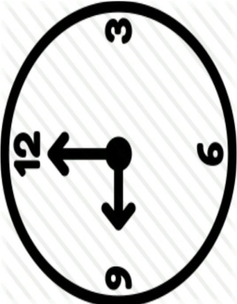 ___________________.

1. Find the even numbers
2. 2 , 5, 7 , 3 , 4 , 9.
3. 1 , 2 , 3, 4 , 5.
4. 4, 5, 6, 7, 8.
5. 10, 11 , 12 , 13, 14.
6. Visual Discrimination : Circle the bigger objects

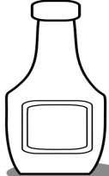



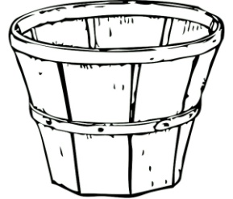

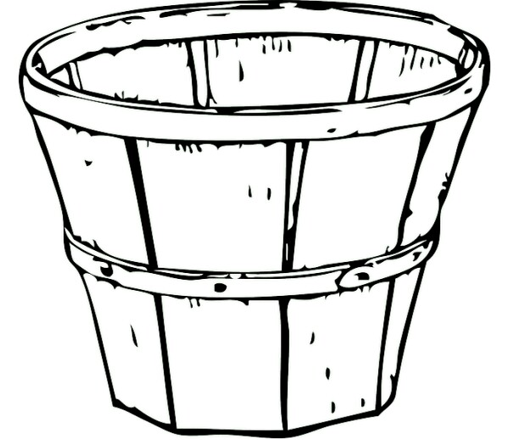

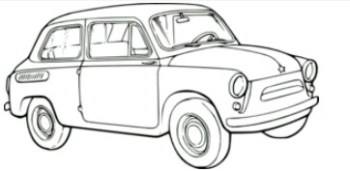



1. Divide each picture into half and shade one part



1. Re – write the numbers in Roman Figures
2. 5 = (b) 7 = (c) 9 = (d) 3 =
3. T U T U

5 3 6 4

+ 2 2 + 2 2

1. Subtraction of numbers Addition of numbers
2. 10 - 3 = (a) 12 + 3 =
3. 6 – 1 = (b) 6 + 2 =
4. 4 - 2 = (c) 5 + 5 =

**PATFIN NURSERY AND PRIMARY SCHOOL, AKESAN, LAGOS STATE.**

**THIRD TERM EXAMINATION [ 2017 / 2018 ]**

**CLASS : NURSERY 1**

**NAME : ______________________________________ SUBJECT: ENGLISH / LETTER WROK**

**INSTRUCTION : ANSWER ALL QUESTIONS DURATION : 1 HOUR**

1. Blending three(3) letter words

H E N B A G L O W

__________ ___________ ___________

N U T R E D

____________ ____________

1. Read and copy simple sentences with three letter words
2. A Hen

_______

1. A Red Hen

__________

1. A Red fat Hen

____________

1. A Red fat Hen sat

________________

1. .

|  |  |
| --- | --- |
| SINGULAR | PLURAL |
| One Cup |  |
| One Bag |  |
| One Mat |  |
| One Boy |  |
| One Hen |  |

1. Write the opposites .

Example : Opposite of “Up” is “Down”

|  |  |
| --- | --- |
| WORD | OPPOSITE |
| HOT |  |
| HAPPY |  |
| GO |  |
| IN |  |
| OLD |  |

1. Circle the noun in each group
2. Go From Bag Slow
3. Church Come Sing Eat
4. Done Have Ibadan Fat
5. Write Do Not Three
6. Bicycle Jump Sleep Run